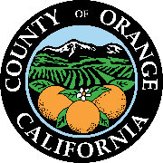  dylan wright  director  oc community resources  cymantha atkinson  assistant director  oc community resources  joanne veedor  director  administrative services  monica schmidt  interim director  oc animal care  julia bidwell  director  oc housing & community development  renee ramirez  director  oc community services  pamela passow  director  oc parks  julie quillman  county librarian  oc public libraries    1501 e. st. andrew place, 1st floor  santa ana, ca 92705  phone: 714.480.6534  fax: 714.480.2978 | 
NOTICE
The Housing and Community Development Commission Meeting

Scheduled For:
March 27, 2025

HAS BEEN CANCELED

THE NEXT MEETING WILL BE HELD ON:

April 24, 2025

For more information you may contact
OCHCDCommission@occr.ocgov.com

